Compressors – Oil Free Scroll Enclosures (10 – 40Hp)-SLP
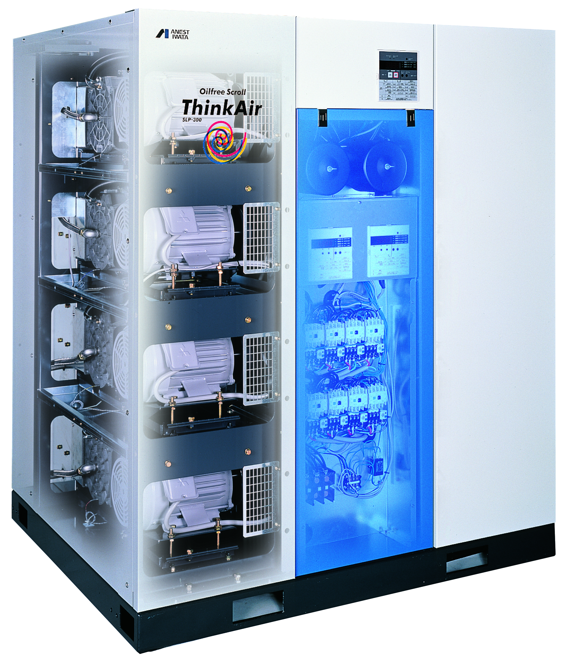

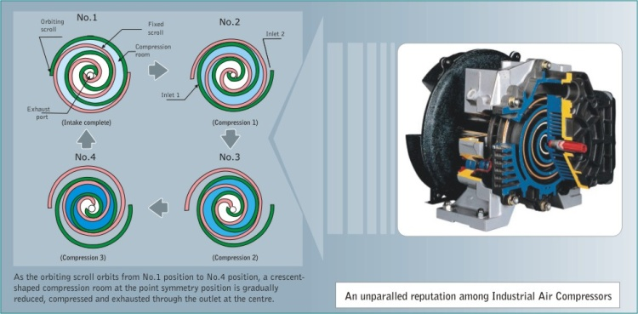
Anest Iwata was the first in the world to develop air-cooled, oil less scroll compressors. Now we have taken our patented scroll technology and incorporated it into our premium line of SL series oil less scroll pumps. As air demand fluctuates during the day, the multiple air-end control systems allows you to adjust and save money. The scroll is the best-selling oil less air compressor.

FEATURES:
- Ultra quiet operation (51-67 dB)
- Energy saving control unit for multiple air-ends
- Clean, 100% oil free air; No oil maintenance required
- Built-in intercooling & runtime monitor sensory
- Digital program display panel
- Very few maintenance intervals
- Small, sleek & compact

SPECS: (Tab)
-- compressor2 (5) pdf—(?)
OPTIONS: (Tab) (**Does not come with storage tank)
- Filter
- Bekomat Membrane Dryer or Refrigerated Dryer (Will be separate from unit)
- Auto-drain sensor (Already included with Refrigerated Dryer)

MANUALS: (Tab)
*Include multiple maintenance and service manuals

